Fix the Sentence
Activity Mat 1
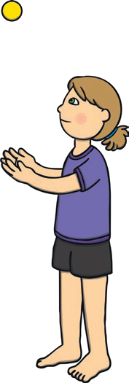
Can you help Mr Whoops to fix these sentences? There is only one mistake in each sentence.

 | the girl threw the ball.
Max |  |  | dug | in | the | soil

Fix the Sentence
Activity Mat 2
Can you help Mr Whoops to fix these sentences?

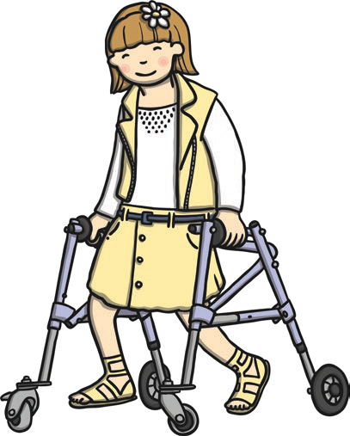

Sasha walked toschool.

Amy likes to plai football.

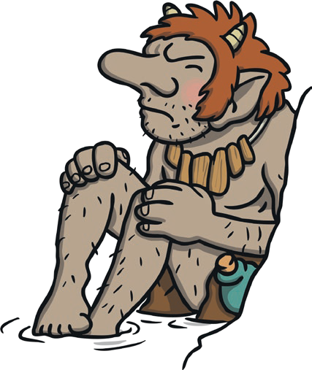
Fix the Sentence
Activity Mat 3
Can you help Mr Whoops to fix these sentences?

The troll si ugly.

Her ice-cream woz chocolate.

