Home should be a safe place but for victims of domestic abuse it is not, in our current climate social distancing and self-isolation has increased the barriers that victims and children face if they are living in an abusive household.

We have launched a Live chat service that is available weekdays 10am to 12pm and 2pm to 4pm to offer another means of communication. The service is available to young people and adults. We need your help to promote it so if you can share the information with colleagues and share our post promoting the helpline on your social media page you can help us to reach people who are in need of support.

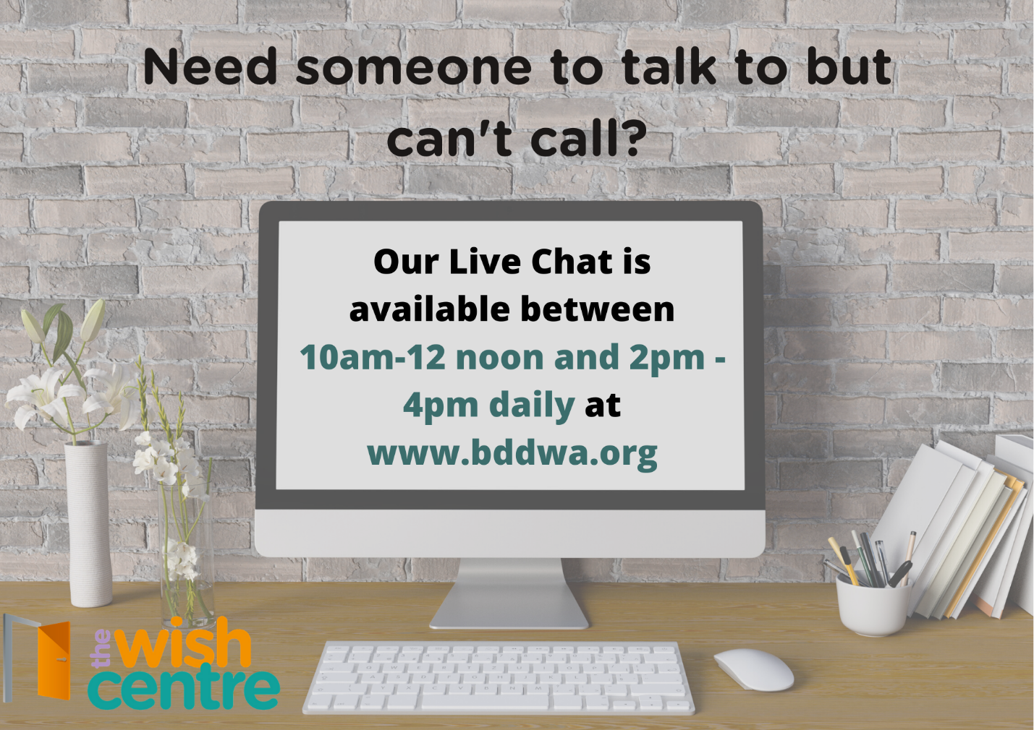

We are also available on our helpline 01254 260465.

